14.03.2016

**INTRO:** Last week I was mainly analyzing papers about the method of different frequency-impedance analysis and their results, like the two that we talked about last time (*Technical report - Harmonic Resonances Associated with Wind Farms* from Lulea University) and a master thesis from Aalto University. I would like to show you some of results I had obtained compering the impedance analysis in DigSilent and analysis performed in Matlab, using basic principles that we were discussing about.

1. In analysis of the thesis from Aalto University, for calculations in matlab, I am implementing model that they assumed in their studies, like the one below:



which is represented for their analysis by the scheme:



I took the values of (R, L, C) elements from the thesis for three voltage levels 8, 33 and 150kV. Then, I converted them to the equivalent model at the highest voltage 150 kV. Similar topology and values I was using for Simulink model that we were talking about, but that time just with one WT and one branch. Btw. Simulink model is now fixed and doesn’t have any unexpected phase shifting.

Again, I have been trying to analyze the case from this paper both in Matlab and DIgSilent. My objective in Matlab was, for three cases, to calculate the equivalent impedances seen from the WT side and then compare results in DIgSilent.

First case, the grid with **only Branch 1** and the rest of elements connecting to the VSC-HVDC. Second case, **two branches** Branch 1 and Branch 2 + the rest of elements like in the scheme. Third case**, whole grid** (Branches 1,2,3,4).

The method is based on what we had discussed i.e. calculation of equivalent impedances for each frequency, assuming elements R, sL and 1/sC in each case. To be more precise, these equivalent impedances are calculated to be seen from the middle point of LCL filter ( dot in the scheme above).

The code is attached in separate file and the results of the obtained impedances, for three cases, you can see in the figures below:

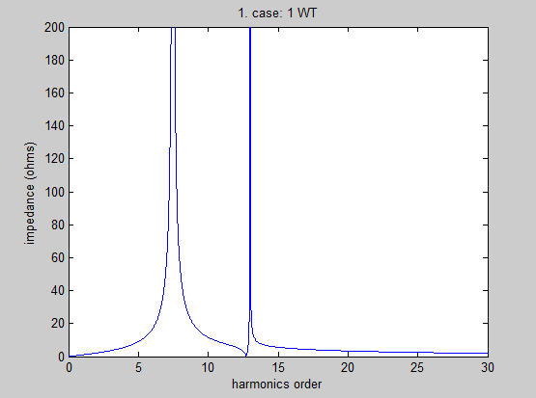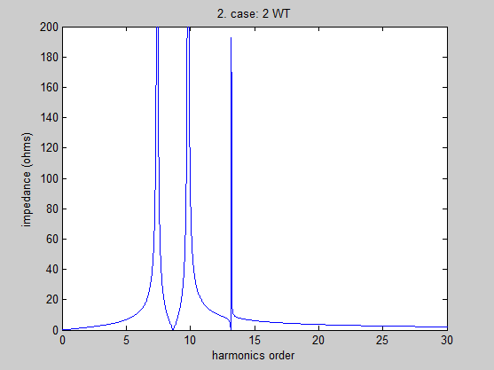

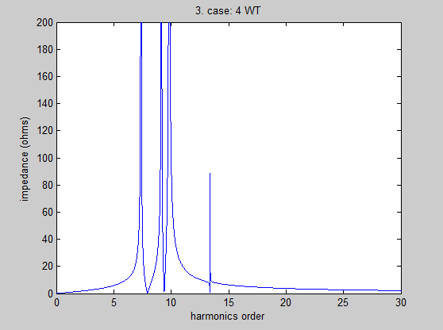

Impedance peaks from case 3 (last graph abouve) are approximately for harmonic orders: **7.35, 9.15, 9.80, 13.4**

Seems like, probably correctly, adding new branches creates new peaking impedance point (parallel resonance), the previous peaks stay more or less the same.

Than, I tried the third case again, but this time with resistance modelled as frequency dependent (proportional to harmonic order. Than, basic elements are: h*R, h*jωL, 1/(h*jωC) ). This does not change critical frequencies but only makes the plot slightly smoother:

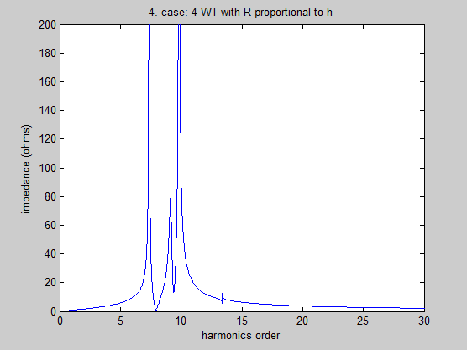

Impedance peaks from case 4 are approximately for frequency orders: **7.35, 9.15, 9.80, 13.4** (last almost shaved). So, introduction of resistance dependency does not influence the harmonic frequencies significantly.When implemented to DIgSilent, but only with pure elements R, L, C, the results of frequency scan for only 1 branch case at all buses (excluding two extreme buses) is:

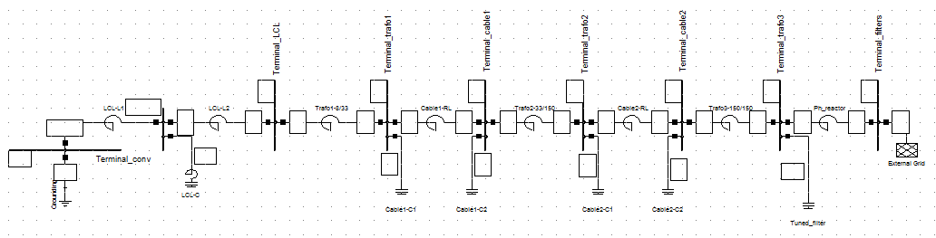

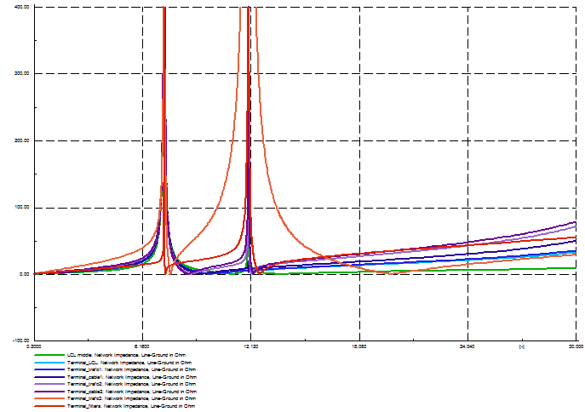

For four branches (3. case referring to previous comparison in Matlab)– similarly:

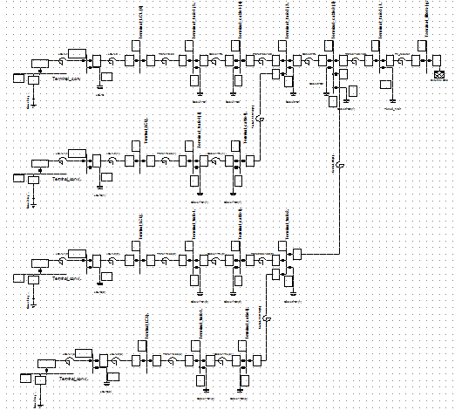

The results of impedances seen from the buses along the first branch:

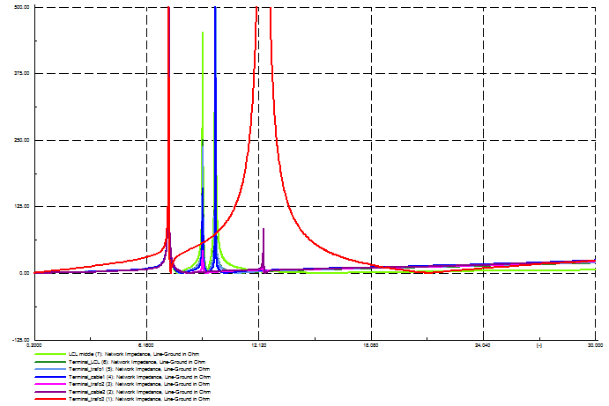

Below, impedances frequency sweep again, but only at the bus simulated in my simulation in matlab, as well as in master thesis from Aalto (middle bus of LCL filter):

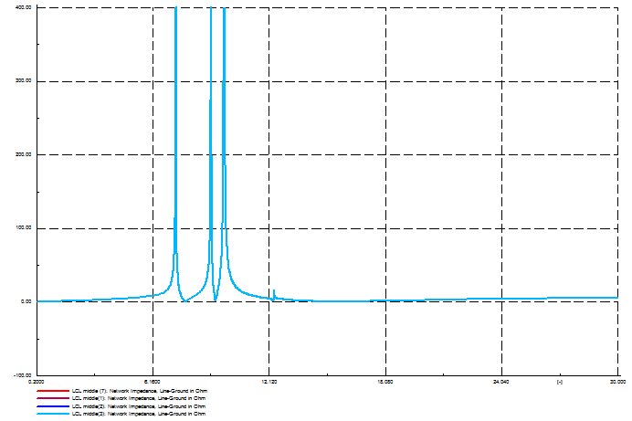

Comparing to the results from matlab:



The harmonic frequencies measuresd in DIgSilent are the same like frequencies obtained in matlab:   
~**7.35, 9.15, 9.80, 13.4.**

However, the frequencies obtained in these two methods do not correspond very well to the frequencies obtained in the thesis from Aalto University. In their analysis the method called “frequency scan” is used, but is seems like the method is the same as the approach we were considering. Basically, in that thesis, frequency scan method is defined as voltages calculated after sinusoidal current with amplitude of 1 per unit and required frequency is injected into a bus:



where Yh is the network admittance matrix, Ih harmonic current matrix and Vh harmonic voltages and the subscript h stands for harmonic order. Above those, not much details are provided in this thesis about their approach to frequency scan. Their results of frequency scan converge well with the other method they use, similar to small signal stability approach.

If this two approaches (frequency scan and how I calculated it) are same, than apparently there is something that is not desribed explicitly in the thesis so I couldn’t include it in my models and recreate it analogically (for example lowest voltage that I had to assume). Or there are mistakes in my calculations, but results are the same in DIgSilent and in Matlab, so hopefully this is not an issue.

1. **Mainly on the basis of the other paper: *Harmonic Resonances Associated with Wind Farms* from Lulea**I have performed similar comparison between values obtained in Matlab by simple impedance equivalent approach and DIgSilent for the simplified windfarm like in the diagram:



And corresponding scheme from DigSilent:

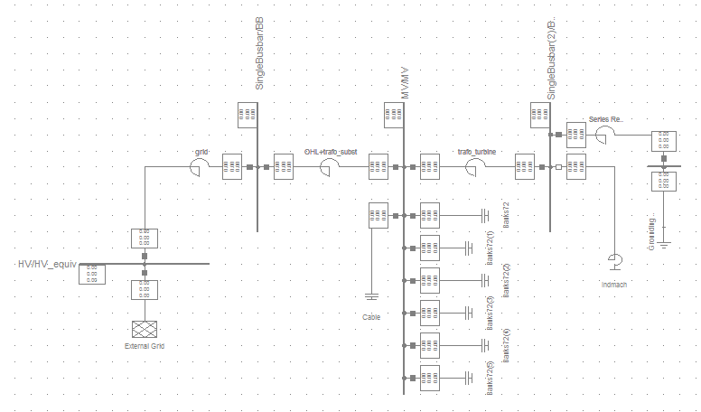

The results are again very similar, at least considering harmonic frequencies. The values of impedances are different, eventhough in this case the base voltages are the same in both simulations.

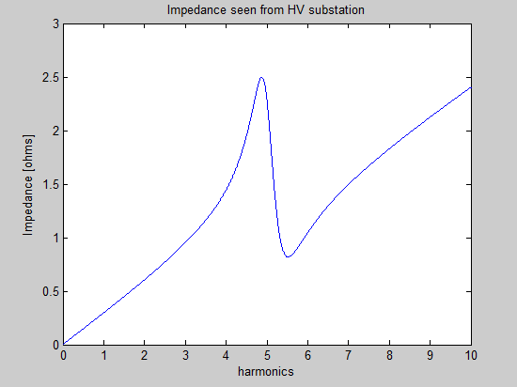 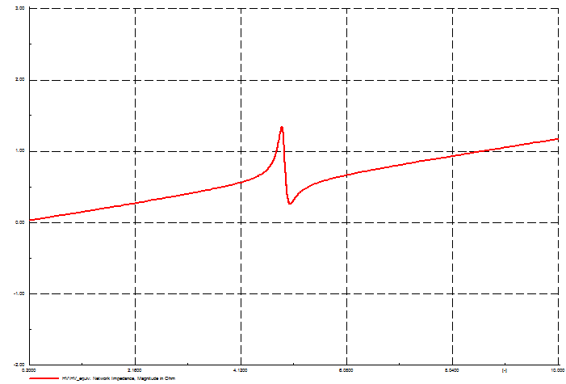

Furthermore, I have obtained the plot of amplification of voltage distortion at the MV bus (see the one-line scheme):

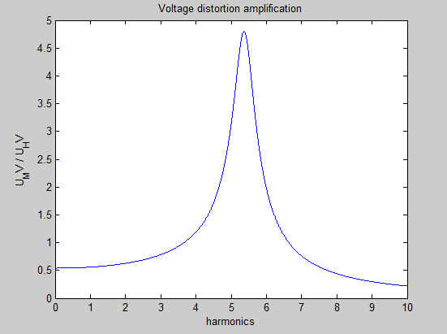

I will analyze the first model (from Aalto report) with respect to the voltage amplification, as well.

Finally, on the basis of this part of initial results included in this document, I would like to ask you about your opinion now about the simplified analysis we had been considering, after I have tried to implement and compare with DigSilent. In my opinion, this approach is eaither very similar or even the same like the one that DigSilent performs in frequency sweep. Anyway, it gives very similar results. Also, it is probably very similar to the one called “Frequency scan” briefly described above and used by authors in the master thesis that I am using data from.

If you find sensible to further delve into this issue, maybe an idea now would be to implement **more complicated WPP**, like couple tens of WTs and than compare results. Also, new WPP would be implemented not with pure elements (RLC) but **using elements provided by DigSilent** and than compare results of harmonics (from impedance and/or voltage distortion) with pure RLC implementation in Matlab.

I would be grateful for your comments and suggestions.